PART-A

A).Agility is both a development philosophy and a collection of concepts embedded into development methodologies. An agile approach to development is essentially a results-focused method that iteratively manages changes and risks. It also actively involves customers, making them in effect a part of the development team. Unlike process-driven documentation, it promotes outcome-driven documentation.
Agile development evangelists tell us that the development should be iterative, with quick turnover, and light on documentation. They are believers in perfection being the enemy of innovation. This is all well and fine, but it does not tell us anything about where to start and how to proceed. Selecting a line of attack is a major obstacle, particularly for an inexperienced developer.

One problem is with this is that when thinking about a development plan, an engineer usually thinks in terms of methodology: what to do first, what next, etc.

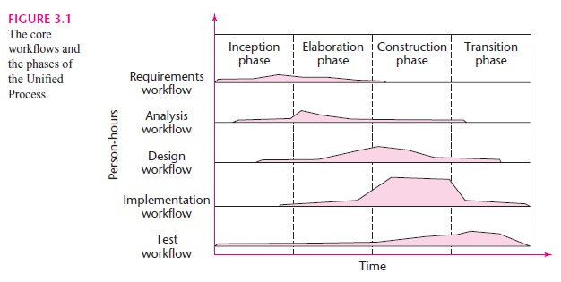
B). Every step performed in the Unifi ed Process falls into one of fi ve core workfl ows and also into one of four phases, the inception phase, elaboration phase, construction phase, and transition phase.

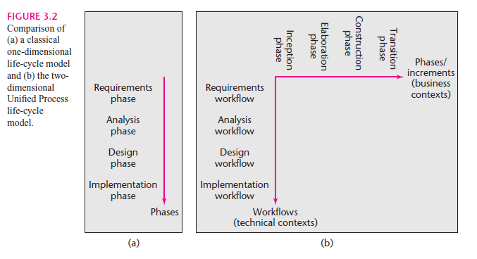

C). Requirements validation examines the specification to ensure that all system requirements have been stated unambiguously; that inconsistencies, omissions, and errors have been detected and corrected; and that the work products conform to the standards established for the process, the project, and the product. The primary requirements validation mechanism is the formal technical review.
The following questions represent a small subset of those that might be asked:
• Are requirements stated clearly? Can they be misinterpreted?
• Is the source (e.g., a person, a regulation, a document) of the requirement identified?
• Is the requirement bounded in quantitative terms?
• What other requirements relate to this requirement? Are they clearly noted via a cross-reference matrix or other mechanism?
• Does the requirement violate any domain constraints?
• Is the requirement testable? If so, can we specify tests (sometimes called validation criteria) to exercise the requirement?
• Is the requirement traceable to any system model that has been created?
• Is the requirement traceable to overall system/product objectives?
D). The software requirements document (sometimes called the software requirements specification or SRS) is the official statement of what the system developers should implement. It should include both the user requirements for a system and a detailed specification of the system requirements.

IEEE standard suggests the following structure for requiremems documents:
I. Introduction
1.1 Purpose of the requiremt:nts document
1.2 Scope of the product
1.3 Definitions, acronyms and abbreviations
1.4 References
1.5 Overview of the remainder of the document
2. General description
2.1 Product perspective
2.2 Product functions
2.3 User characteristics
2.4 General constraints
2.5 Assumptions and dependencies
3. Specific requirements cover functional, non··functional and interface requirements. The requirements may document external interfaces, describe system functionality and performance, specify logical database requirements, design constraints, emergent system properties and quality characteristics.
4. Appendices
5. Index

E). cohesion and coupling.
Cohesion is a measure of the relative functional strength of a module. Coupling is a measure of the relative interdependence among modules. Cohesion may be represented as a "spectrum." We always strive for high cohesion, although the mid-range of the spectrum is often acceptable.
The scale for cohesion is nonlinear.Coupling is a measure of interconnection among modules in a software structure. Coupling depends on the interface complexity between modules, the point at which entry or reference is made to a module, and what data pass across the interface.In software design, we strive for lowest possible coupling. Simple connectivity among modules results in software that is easier to understand and less prone to a "ripple effect", caused when errors occur at one location and propagate through a system.

F) As any quality assessment, we start with metrics. we have to define proper metrics to get the right information out of your quality effort. If we use metrics that are not aligned to what we want, we will not get closer to your goal.
That's why we will find many different ways to assess software design quality, depending on the methodology we are using. The most commonly used, unfortunately, is binary: Is the design done, yes/no? And even then "done" is vaguely defined.
As an example: For a business application, using a classic waterfall scenario, we did proper analysis first, documenting all use cases and getting shareholders signoff of those requirements; then we produce an E-R database diagram, a module / class diagram, and some specs for the major workflow logic. Assuming this methodology and scenario, we can measure coverage of our use cases as they are related to the proposed implementation; measure normalization of our database model; and complexity metrics like cyclomatic complexity.

G). Cyclomatic complexity is a software metric that provides a quantitative measure of the logical complexity of a program. When used in the context of the basis path testing method, the value computed for cyclomatic complexity defines the number of independent paths in the basis set of a program and provides us with an upper bound for the number of tests that must be conducted to ensure that all statements have been
executed at least once.
H). IEEE suggests a software maturity index (SMI) that provides an indication of the stability of a software product (based on changes that occur for each release of the product). The following information is determined:
MT = the number of modules in the current release
Fc = the number of modules in the current release that have been changed
Fa = the number of modules in the current release that have been added
Fd = the number of modules from the preceding release that were deleted in the current release

The software maturity index is computed in the following manner:
SMI = [MT _ (Fa + Fc + Fd)]/MT
I). Software reliability, unlike many other quality factors, can be measured directed and estimated using historical and developmental data. Software reliability is defined in statistical terms as "the probability of failure-free operation of a computer program in a specified environment for a specified time"
If we consider a computer-based system, a simple measure of reliability is meantime- between-failure (MTBF), where MTBF = MTTF + MTTR
The acronyms MTTF and MTTR are mean-time-to-failure and mean-time-to-repair, respectively.

J) It is not necessary that a correct program would exhibit good quality. For example, a program may be correct but the logic may be such that it does not efficiently utilize the system resources. As a result, the quality of the product may not be too good. A good quality program should utilize the system resources efficiently and the output should be produced in a minimum possible time. A good quality software must be delivered on time and within budget, and should be maintainable.

PART-B

2 A). PROCESS ASSESSMENT
- It attempts to keep a check on the current state of the software process with the intention of improving it.
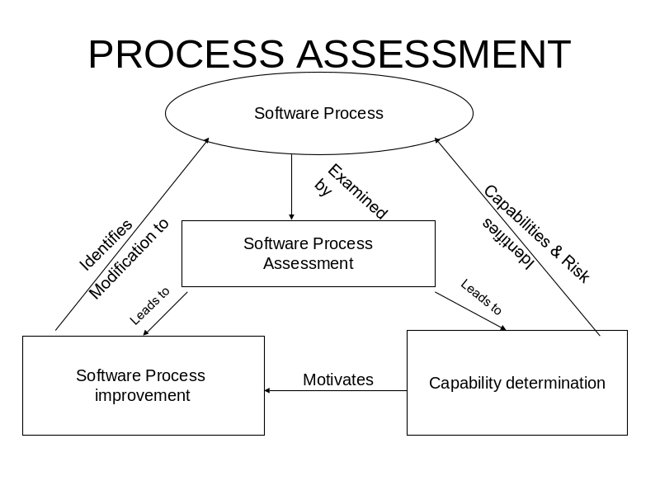
- Standard CMMI assessment for process improvement (SCAMPI): provides a 5 step process assessment model that incorporates initiating, diagnosing, establishing, acting and learning. The SCAMPI uses SEI CMMI as basis for assessment.
- CMM based appraisal for internal process improvement: provides a diagnostic technique for assessing relative maturity of a software organization
- SPICE(ISO/IEC 15504):standard defines a set of requirements or sotware process assessment
- ISO 9001:2000 for software: is a generic standard that applies to any organization that wants to improve overall quality of products, systems or services that it provides.

2 B). Spiral model
- This is a model proposed by boehm it is an evolutionary model which combines the best feature of the classical life cycle and the iterative nature of prototype model
- Include new element : Risk element
- Starts in middle and continually visits the basic tasks of communication, planning,modeling,construction and deployment
- Using spiral model,software is developed in a series of evoltionary releases.During early iterations,the release might be a model or prototype.During later iterations increasinly more complete versions of engineered system are produced
- Realistic approach to the development of large scale system and software
- Unlike other process models that end when software is delivered,the spiral model can be adapted to apply through out the life of computer software.Therefore the first circuit around the spiral represent a “concept development project” which starts at the core of the spiral and contines for multiple iterations until concept development is complete.If the concept is to be developed into an actual product,process proceeds outward on the spiral and a “new product development project “commences.The new product will evolve through a number of iterations around the spiral.Later,a circuit around spiral might be used to represent a “product enhancement project”.The spiral remains operative until the software is retired.
- It is difficult to convince customers that the evolutionary approach is controllable.

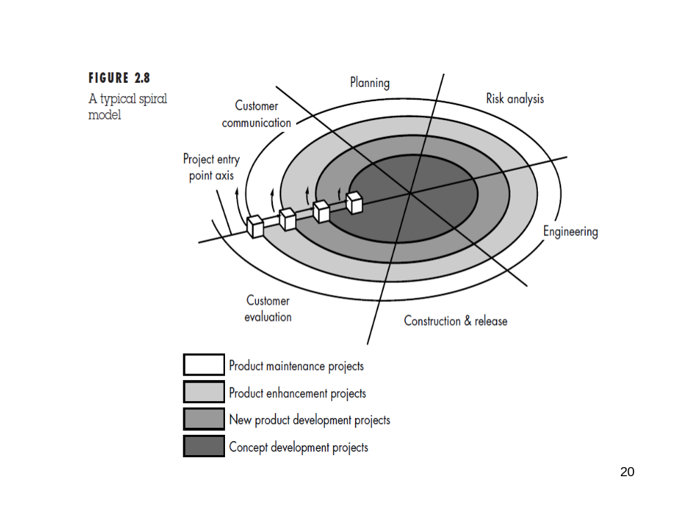

3.A) 5 Generic process framework activities
Ans: CPMCD
B) CAPABILITY MATURITY MODEL INTEGRATION
Developed by SEI(Software Engineering institute)
Assess the process model followed by an organization and rate the organization with different levels
A set of software engineering capabilities should be present as organizations reach different levels of process capability and maturity.
CMMI process Meta model can be represented in different ways
1. A continuous model
2. A staged model
Continuous model: Six levels of CMMI
  - Level 0:Incomplete
  - Level 1:Performed
  - Level 2:Managed
  - Level 3:Defined
  - Level 4:Quantitatively managed
  - Level 5:Optimized

INCOMPLETE -Process is adhoc.Objective and goal of process areas are not known
Performed All the specific goals and practices process area have been satisfied but performance may not be stable they do not meet some specific objectives such as quality, cost and schedule
Managed -Activities are monitored, reviewed, evaluated and controlled to achieve a given purpose and cost, schedule, quality are maintained.
Defined -All level2 criteria have been satisfied and in addition process are well defined and are followed throughout the organization
Quantitatively Managed -Metrics and indicators are available to measure the process and quality
Optimized (perfect&complete)- Continuous process improvement based on quantitative feedback from the user
Staged model
- This model is used if you have no clue of how to improve the process for quality software.
- It gives a suggestion of what things other organizations have found helpful to work first
- Levels are called maturity levels

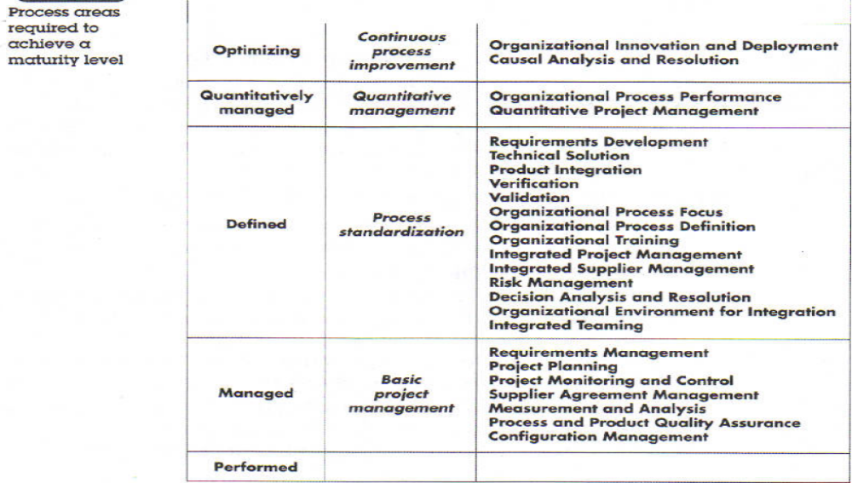

4 A). Requirements analysis is a software engineering task that bridges the gap between system level requirements engineering and software design Software requirements analysis may be divided into five areas of effort:
(1) problem recognition, (2) evaluation and synthesis, (3) modeling, (4) specification, and
(5) review.
Initially, the analyst studies the System Specification (if one exists) and the Software Project Plan.

Eliciting and understanding stakeholder requirements is difficult for several reasons:
- Stakeholders often don't know what they want from the computer system except in the most general terms.
- Stakeholders naturally express requirements in their own terms and with implicit knowledge of their own work. Requirements engineers, without experience in the customer's domain, must understand these requirements.
- Different stakeholders have different requirements, which they may express in different ways.
- Political factors may influence the requirements of the system. For example, managers may demand specific system requirements that will increase their influence in the organization.
- New requirements may emerge from new stakeholders who were not originally consulted.

4. B) Structured analysis, is a classical modeling method and is a model building activity Structured analysis is not a single method applied consistently by all who use it. Rather, it is an amalgam that evolved over more than 30 years.
1.Creating an Entity/Relationship Diagram
2.Creating a Data Flow Model; A data flow diagram (DFD) is a graphical representation of the "flow" of data through an information system, modelling its process aspects. A DFD is often used as a preliminary step to create an overview of the system, which can later be elaborated
3.Context diagrams are diagrams that represent the actors outside a system that could interact with that system. This diagram is the highest level view of a system, similar to Block Diagram
4.Creating a Control Flow Model

5) Functional and non-functional requirements
Functional requirements
  - Statements of services the system should provide, how the system should react to particular inputs and how the system should behave in particular situations.
  - Describe functionality or system services.
  - Depend on the type of software, expected users and the type of system where the software is used.
Complete They should include descriptions of all facilities required.
Consistent There should be no conflicts or contradictions in the descriptions of the system facilities.
In practice, it is impossible to produce a complete and consistent requirements document.

Non-functional requirements
  - Constraints on the services or functions offered by the system such as timing constraints, constraints on the development process, standards, etc.
  - These define system properties and constraints e.g. reliability, response time and storage requirements.
  - Non-functional requirements may be more critical than functional requirements. If these are not met, the system is useless.
Non-functional classifications
1. Product requirements These requirements specify product behaviour.Examples include performance requirements on how fast the system must execute and how much memory it requires; reliability requirements that set out the acceptable failure rate; portability requirements; and usability requirements.

2. Organisational requirements these requirements are derived from policies and procedures in the customer s and developer s organization. Examples include process standards that must be used; implementation requirements such as the programming language or design method used; and delivery requirements that specify when the product and: Its documentation are to be delivered.
3. External requirements This broad heading covers all requirements that are derived from factors external to the system and its development process. These may include interoperability requirements that define how the system interacts with systems in other organizations: legislative requirements that must be followed to ensure that the system operates within the law; and ethical requirements. Ethical requirements are requirements placed on a system to ensure that it will be acceptable to its users and the general public.
Non-functional requirements examples.
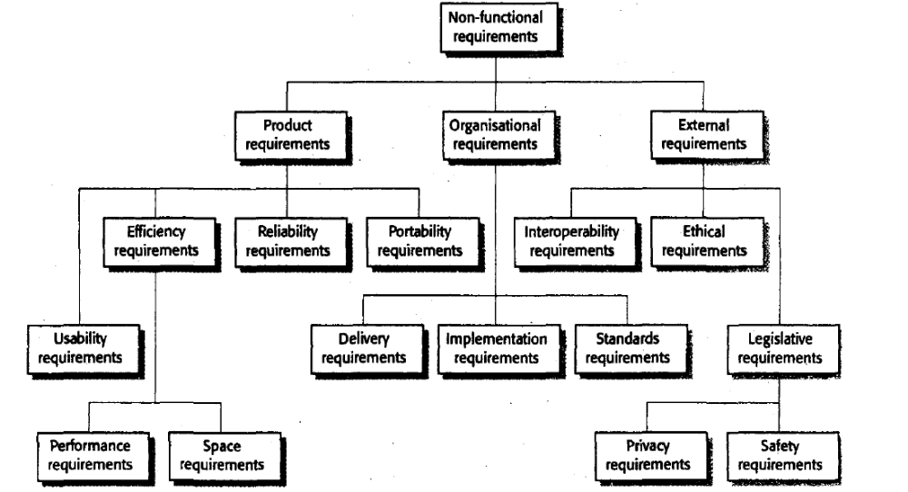

6) What are the factors that influence software quality?
- Clear purpose of the product. All documentation must be clearly written.
- Completeness to the fullest development of the product.
- Only needed information and minimum lines of code should present. It is important as the memory is limited.
- The software product should be portable, so that computers of various configurations would support the execution of the product.
- Product should be maintainable, so that the updating activity can be continued throughout the life time of the software product.

